JAT TASK-12

1.

Query to insert values

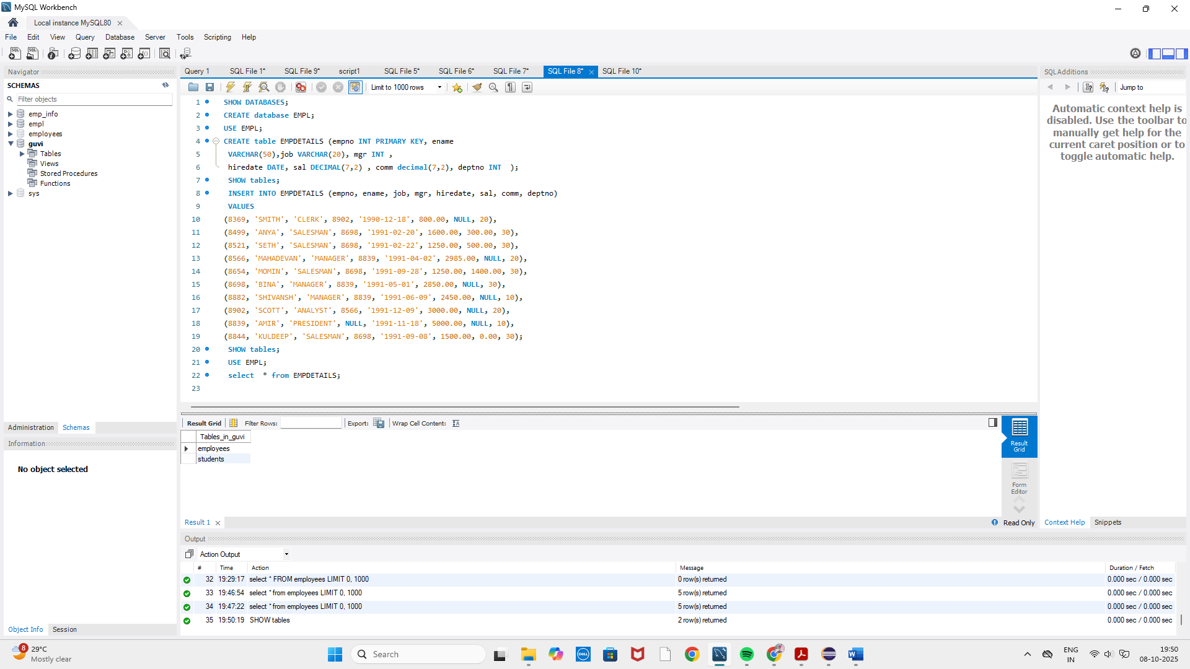

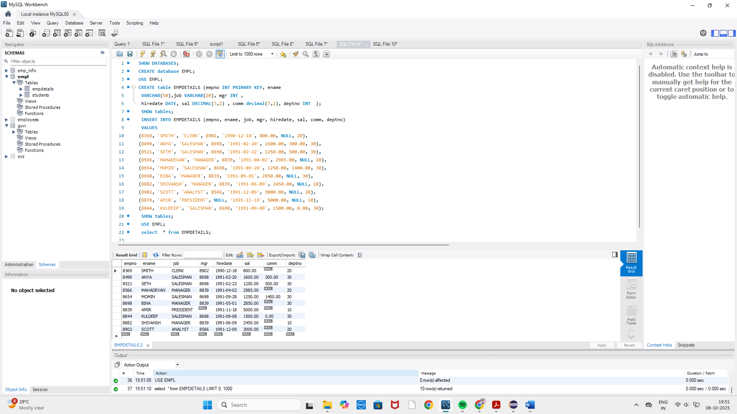

Query to display ename and sal of employees whose salary is greater than 2000

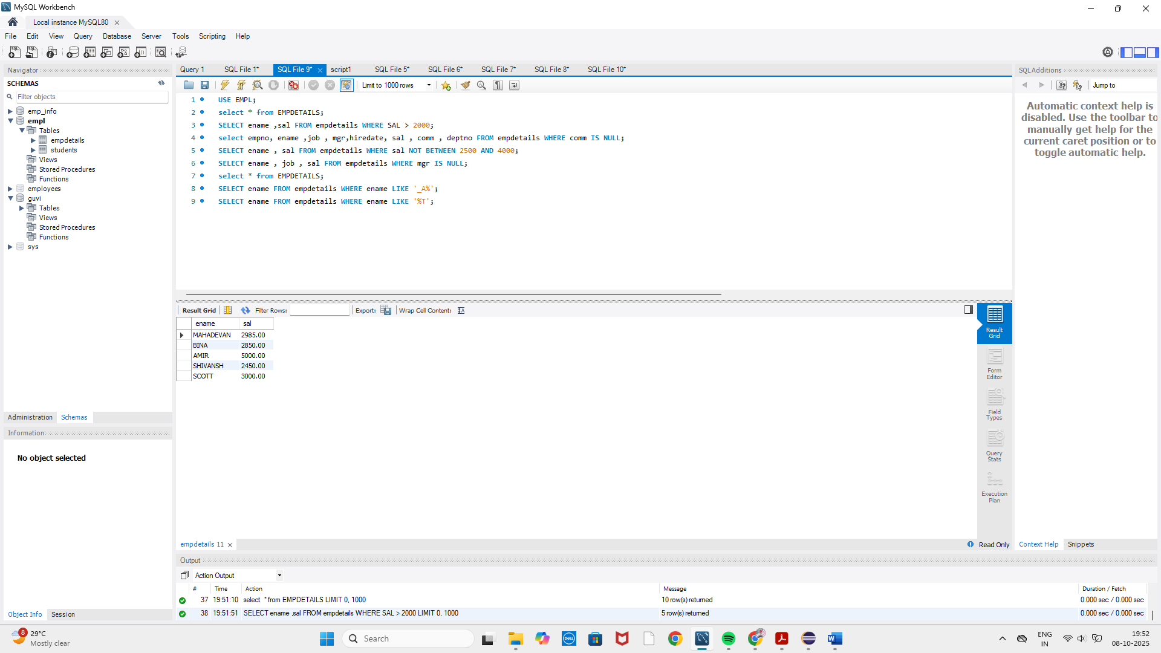

Query to display empno,ename, sal,job,mgr,hiredate comm and deptno of employees whose comm is null.

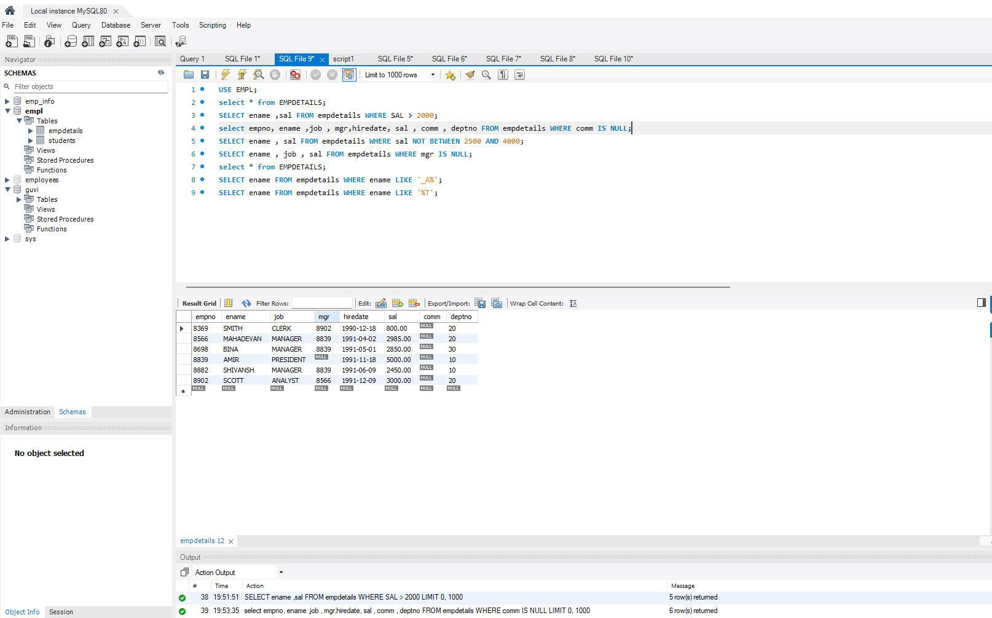

Query to display ename and sal of employees whose salary doesnot lie between 2500 and 4000

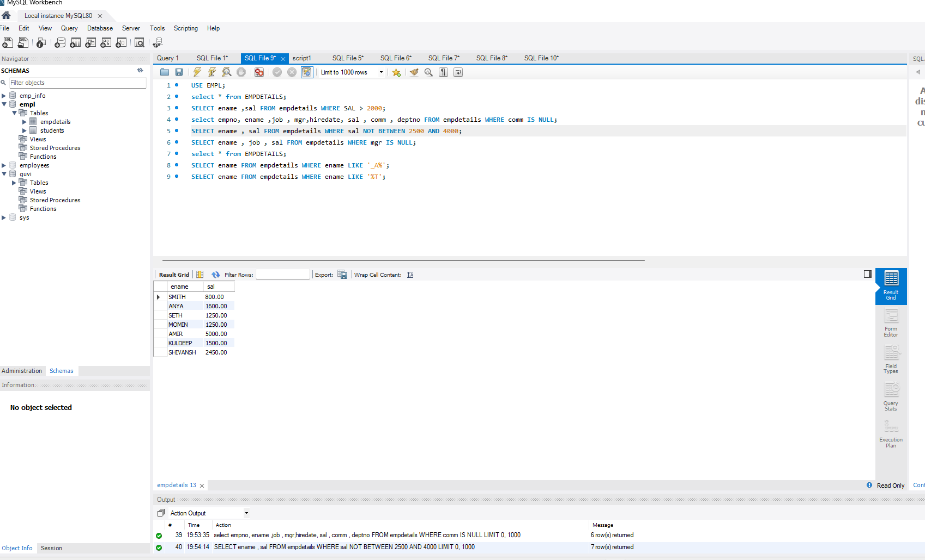

Query to display ename job and sal of employees whose mgr is null

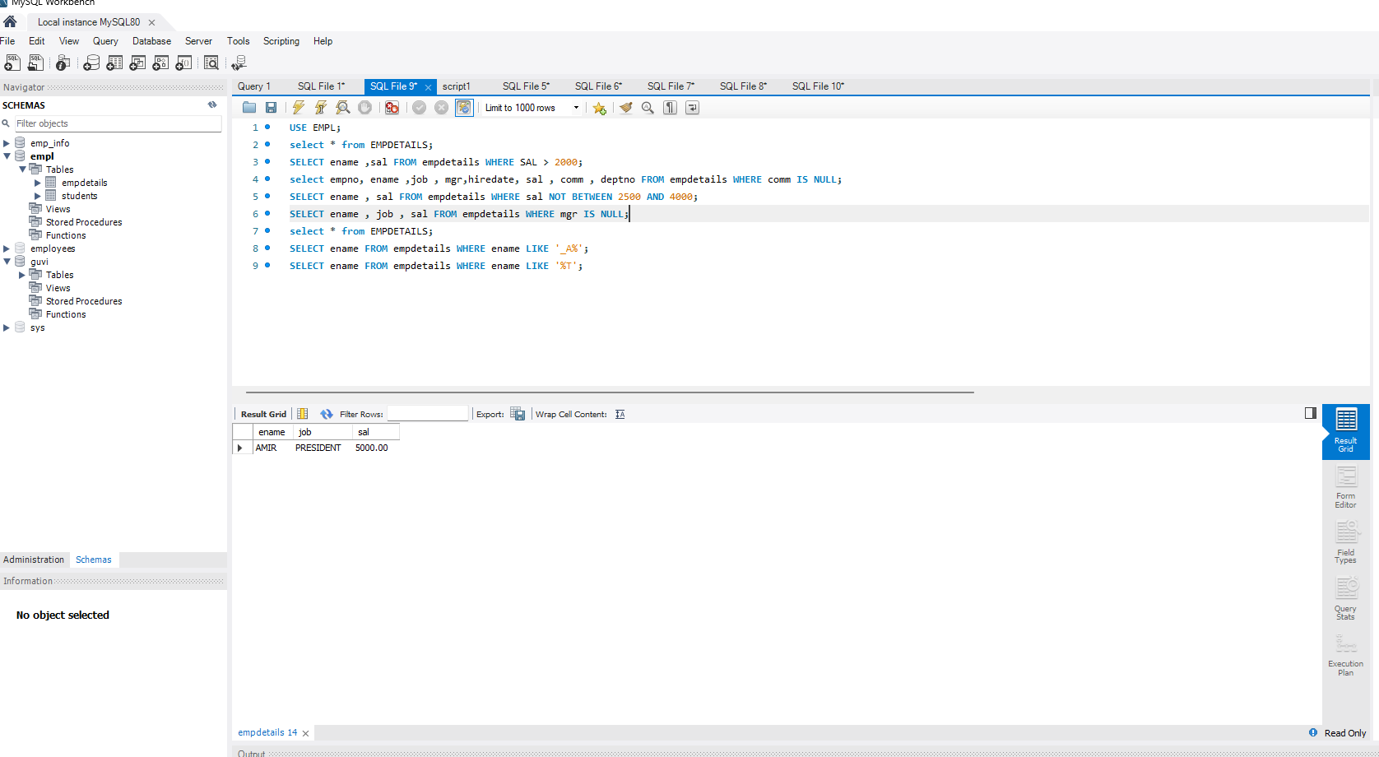

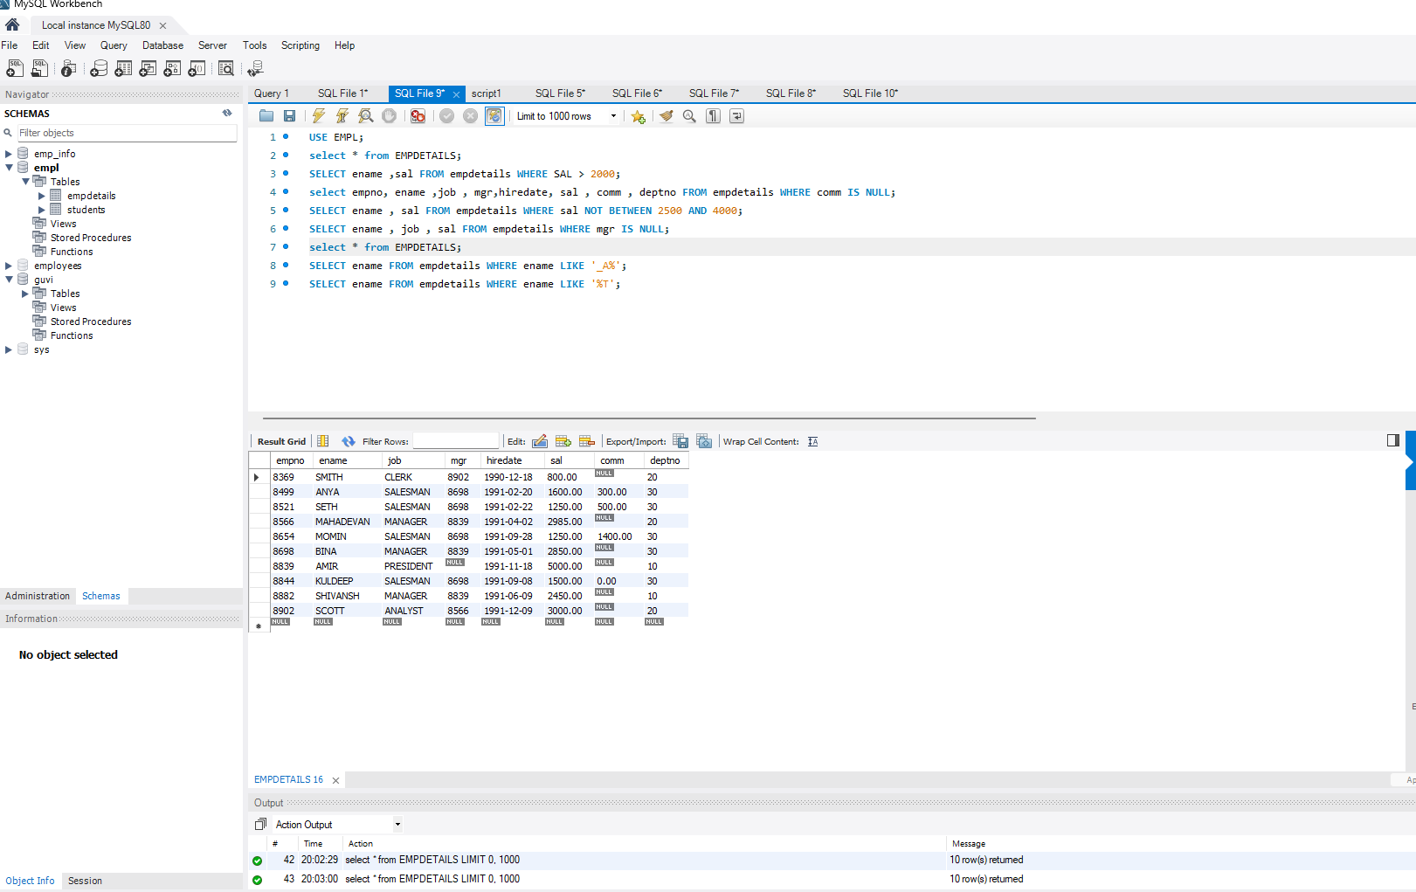

Query to display ename of employees whose second letter is ”A”

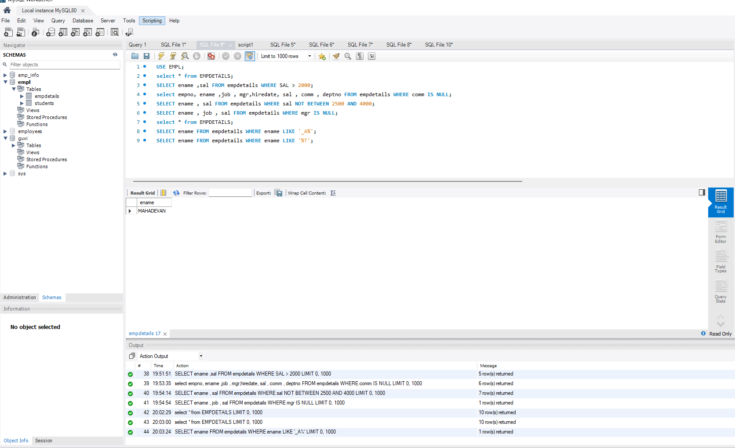

Query to display ename of employees whose name’s last letter is ”t”

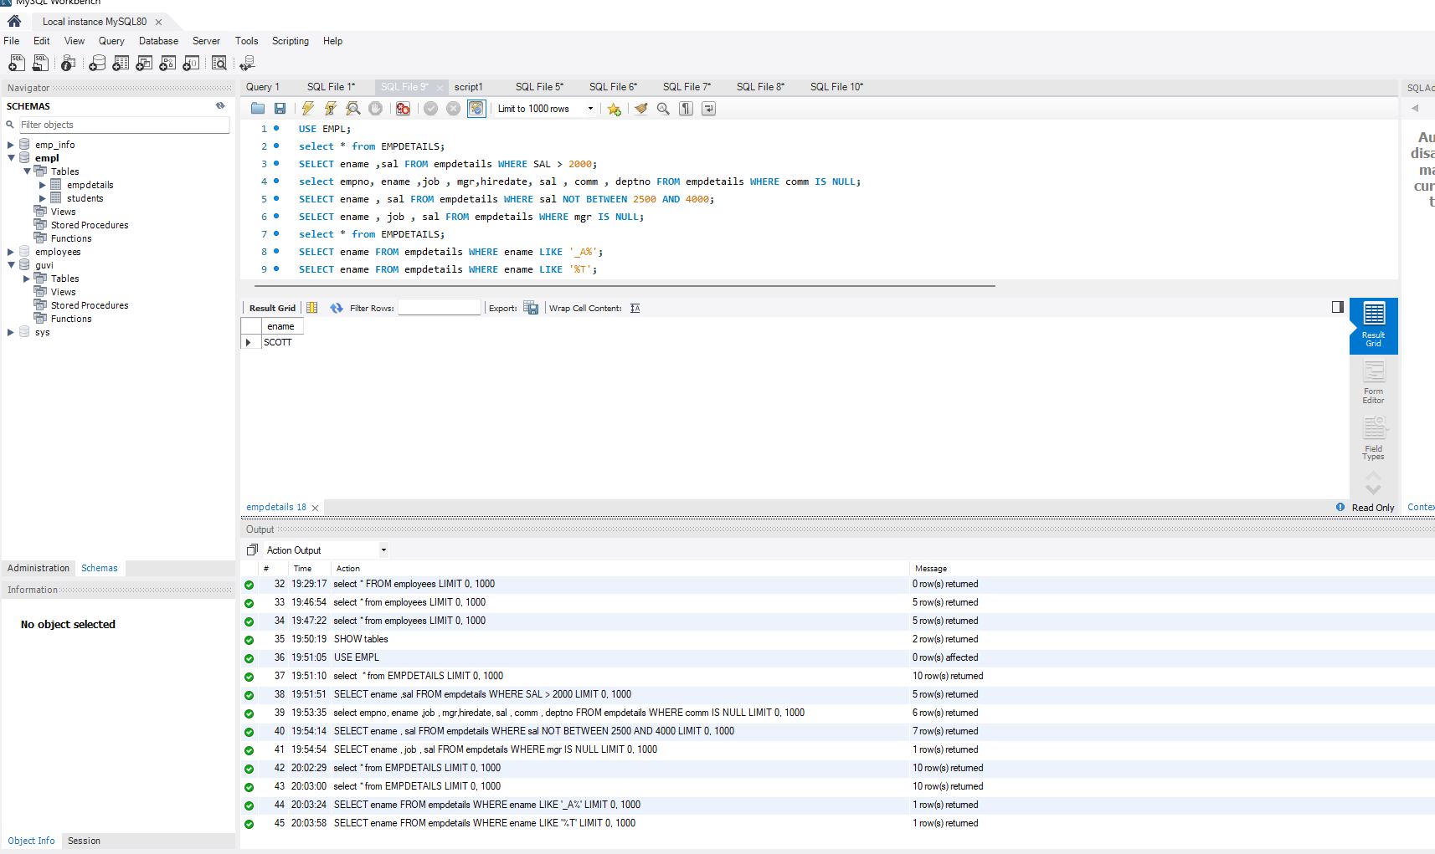

2. JDBC program

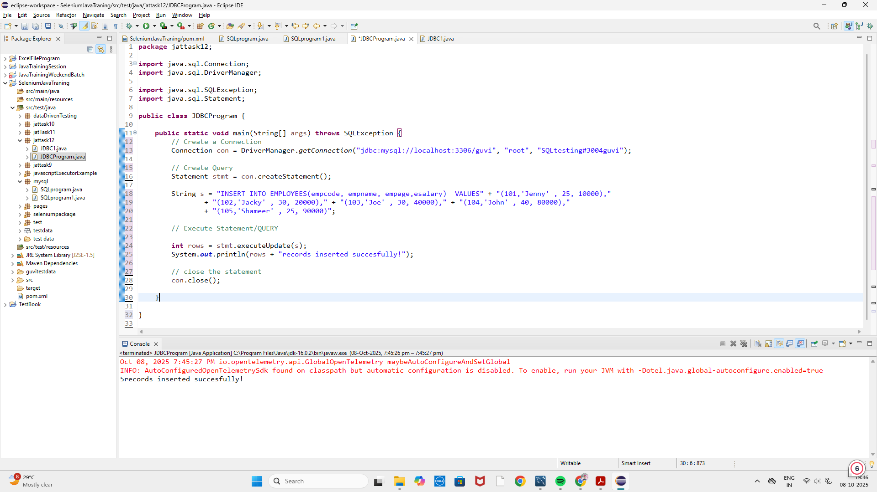

MYSQL

